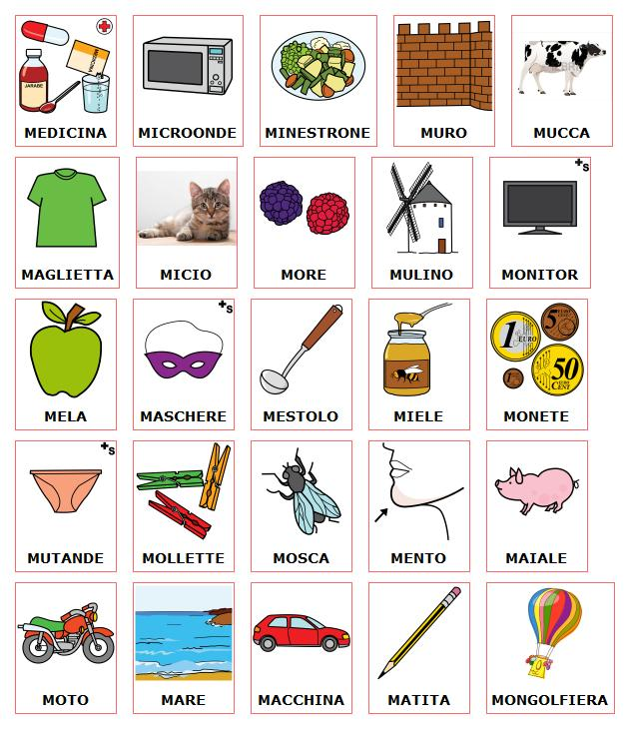

Pictograms’ author: Sergio Palao Origin: ARASAAC (http://arasaac.org) Licenses: CC (BY-NC-SA) Property: Aragon Goberment

MA | ME | MI | MO | MU

